Agenda AGM 11th October 2010

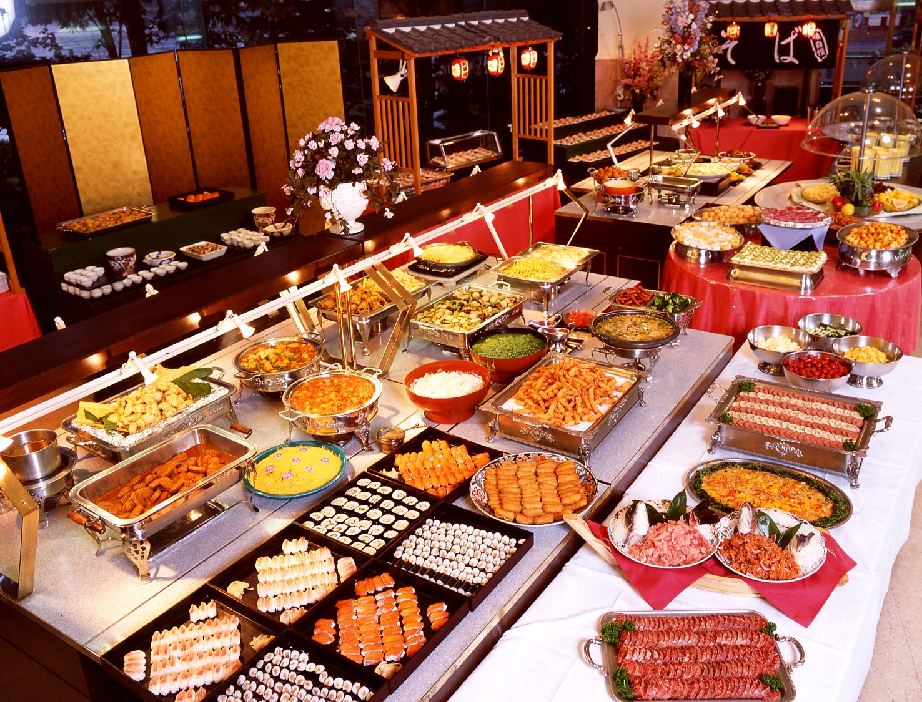
7:30 – 8:00pm – Buffet food (please help yourself) and automated slide-show of club photographs and activities over the year.

8:00 – 8:20pm - AGM (Election of Club Officials, Paddler of the Year, Members Motions)
1. Apologies for Absence. M Alter, C Turner, M Turner
2. Minutes of the previous AGM
- Signed as a true record by the Chair
- Matters arising.
3. Treasurers report Online Year End Accounts
4. Members motions
Motion 1/ That membership fees be increased to cover the operating costs of the club. Following the development over the past year (fleet of canoes and kayaks, winter pool sessions and establishment of a base at the marina including racking, a shed and floating pontoons) the cost of running the club have risen significantly. Suggested annual membership fees: Adult - £10, Family - £15, Junior £5, Active Coaches – £0, Associate / web only member - £0 (Proposer Brian Green, seconded M Alter)
Motion 2/ Information point (for discussion). To cope with the demand for coaching courses it is proposed to charge a small fee (£10 per course) to those signing up for courses (ie 5 week introductory course). A proportion (5/8`s) of this will be available as contribution towards petrol / travel costs for a coach who runs the course. Hopefully, this will mean that we can offer more courses and meet the needs of our members. (Proposer Keith Steer, Seconded Ian Bell)
Motion 3/ That we look at 4 club Awards for next year. Junior paddler of the year, Senior paddler of the year, Volunteer of the year and Swimmer of the year. (Proposer Keith Steer, Seconded Steve Bond)

5. Election of Officers.
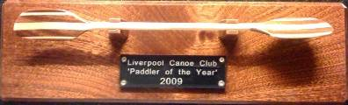
- Chair – Dominic Buckley (Proposed Keith S, 2nd Steve Bond), c – ?, Hon Treasurer Sam Godsell (Proposed by Jim Slater and seconded by Jon Strange)
- “Discipline Representatives” to advise members / act as a point of contact (Sea, Open Boat, Coaching, Freestyle, Rivers, Polo, Kayak Safety Cover)
- Other key posts: Fundraising and publicity, Notice boards, Website and communications, membership secretary and Kingsway pool collector of money.
6. Paddler of the Year / Swimmer of the Year Award – Presented by the chair.

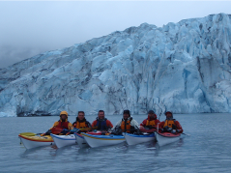
8:20 to 9:30pm - Club expedition to Prince William Sound – Alaska (Presentation by the expedition members)

9:30pm onwards – Socialise in the bar.

