Agenda AGM 13th October 2014

7:30 – 8:00pm – (Automated slide-show of club photographs and activities over the year.

8:00 – 8:30pm - AGM (Election of Club Officials, Paddler of the Year, Members Motions)
Welcome from the chair & review of the year
1. Apologies for Absence.
2. Minutes of the previous AGM – Click here
- Signed as a true record by the Chair
- Matters arising.
3. Treasurers report Online Year End Accounts – Click here
4. Brief reports from each discipline (2 minutes each)
5. Members motions –
i) Free Coach membership should be widened to include club volunteers “who make a significant contribution to the running of the club”(Keith Steer)
ii) Discontinue non-paddling membership category as it is redundant with all the important information now freely available on the website. Past members still receive information from media groups unless they unsubscribe. It may be actually preventing some from joining as a full member if they loose password. (Keith Steer)
6. Election of Officers – Proposed list of those willing to stand for 2014-15

- Chair – Fiona Barry; Secretary – Frankie Annan, Treasurer - Sam Godsell; Membership Secretary & Volunteers – Keith Steer; Welfare Officers - Frankie Annan & Dominic Buckley. Publicity – Pete Thomas; Social Events – Fiona Barry, Joanne Fisher & Jeanette Bond; Grants-Vacant?
- “Discipline Representatives” to advise members / act as a point of contact:
Coaching – Ian Bell, Assistant Coach Carl Leungsangnam; Junior / Youth Coordinator – Chris Murphy; Notice boards - Peter Massey; Kingsway pool on Thursday Chris Murphy & Roy McHale to stand down. Proposed Fiona Barry to oversee the running of the pool; Kingsway pool on Monday Stuart Toulson & John Cooke; Equipment Officers – John Pegram & Steve Bond, Dave Brown, Charles Andersen, Don Brooks, Mike Hughes, John Worswick & Tony Doyle; Polo –Scott Gibson, Sea – Brian Green; White Water –Roy McHale & Mark Young ; Freestyle Mark Garrod to stand down Proposed Sam Preston & Kieran Sinnott ; Open Boat – Paul Harwood to stand down. Proposed Mike Alter & Ruth Edwards; Kayak Safety Cover – John Worswick; Slalom – Michal Giezgala; Racing - Vacant?; Surf - Proposed Paul Harwood & Karl Tattum;
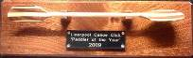
7. Paddler of the Year / Young paddler of the Year / Volunteer of the Year / Swimmer of the Year Award – Presented by Fiona Barry.

8:30 – 8:45pm – Buffet food – provided free – please help yourselves
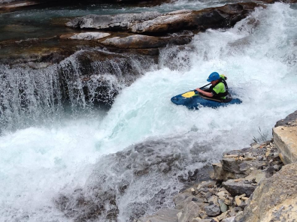
8:45 to 9:30pm - Club expedition to Briancon – French Alps (World Premiere of - Alps Video 2014 by “Never again Productions”

9:30pm onwards – Socialise in the bar.

