Agenda AGM 17th October 2018

7:30 – 8:00pm – Arrival Liverpool Marina, Spinnaker Suite. Slide-show of club photographs and activities over the year.

8:00 – 8:20pm - AGM (Election of Club Officials, Paddler of the Year, Members Motions)
Welcome from the chair & review of the year
1. Apologies for Absence.
2. Minutes of the previous AGM – Click here
- Signed as a true record by the Chair
- Matters arising.
3. Treasurers report Online Year End Accounts – Click here
4. Brief reports from each discipline (2 minutes each)
5. Members motions – None received to date.
6. Chair to thank all the volunteers that have coordinated and guided the club over the past year.
Kingsway pool on Monday - Robin Emery; SUP - Paul Harwood; Equipment Officers Steve Bond & Don Brookes (Docks and Broadgreen); Stewardship Group Chris Fletcher.
7. Election of Officers – Proposed list of those willing to stand for 2018-19
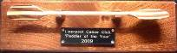
Chair – Fiona Barry; Secretary – Carole Thomas, Treasurer & Grants – Craig Ford; Membership Secretary & Volunteers – Keith Steer; Lead Safeguarding Officer – John Fay, Assistant Safeguarding Officer Karl Tattum; Publicity – Pete Thomas; Junior / Youth Coordinator – Ian Colwyn; Notice boards - Peter Massey; Kingsway pool on Monday Dominic Fahey; Stuart Conway; Nick Coughlin; Dave Reynolds & Keith Steer;
“Discipline Representatives” to advise members / act as a point of contact: Coaching Coordinator – Dave Reynolds, Technical Coaching Advisor – Ian Bell; Polo – Josh Cook, Sea – Gareth Jones; White Water – John Allerton and Stuart Toulson; Freestyle - Graham Devaney; Open Boat – Mike Alter & Ruth Edwards; Kayak Safety Cover –Jim Duffy assisted by Dave Rider; Slalom – Michal Giezgala; Racing – Colin Smith; Surf – Karl Tattum, SOT – Dermot Miller SUP - Jayne Rigby
Equipment Officers: Craig Ellingham & Alex Peacock Maintenance Coordinator (Docks), Steve Alcock (Docks and Broadgreen); (Kingsway) Dominic Fahey
“Election of Stewardship Group members without specific responsibility” John Pegram, Julie Brookes & Dave Collins
8:20 to 8:45pm
8. Paddler of the Year Awards presented by the chair. This year saw a limited number of nominations, so a vote was not required. Congratulations to:

2018 Paddler of the Year | 2018 Junior of the Year | 2018 Volunteer of the Year | 2018 Swimmer of the Year
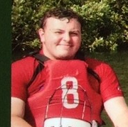 | 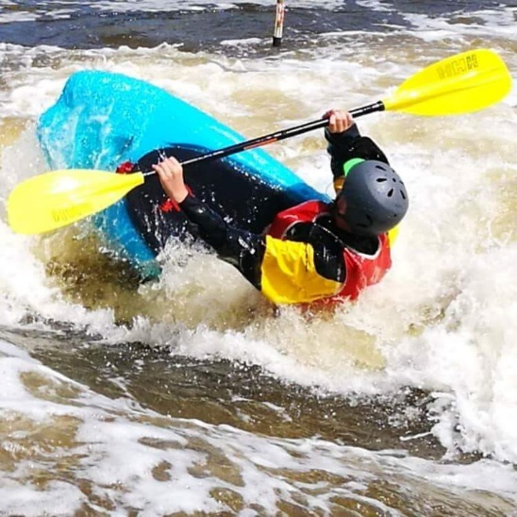 | 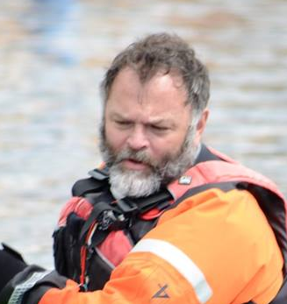 | 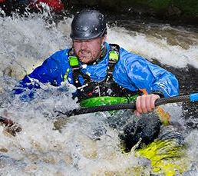
Aaron Jackson | Harvey Harwood | Colin Muse | Graham Devaney
Aaron as helped lead the U18 polo team to great success this year and is always willing to help, often putting others before himself. He is developing his coaching and helps run dock sessions. Nothing is ever too much trouble. Stanley Embankment has become a firm favourite of his and his paddling confidence has come on leaps and bounds over the season. He is an inspiration to all. | Harvey has had a tough time this year. He was unable to paddle until June but has made the most of his trips to Stanley Embankment, Tees Barrage, Llangollen and numerous surf sessions to Crosby and Anglesey. He hasn't swum once so far this year, which is amazing seeing how much time he spends upside down. | Colin has consistently helped at pool sessions throughout the year and has been the “main driver” of the beginners’ courses at the docks. He is always the first to greet both new and existing members. | Whilst paddling on the club trip to the French Alps Graham broke out into a strong eddy on the Middle Durance (Grade 1-2). He capsized and struggled to roll and baled almost immediately. Some of us ran as fast as we could upstream, not to help with any impending pin, but rather to take photo and video evidence which will be released at the AGM

8:45 to 9:30pm - Club expeditions to France, Nepal and Alaska
(The best photos and World Premiere of - French paddling movie 2018)

9:30pm onwards – Socialise in the bar.

