Agenda AGM / Paddler of the year Awards and
club presentations of major trips Thursday 10th October 2019

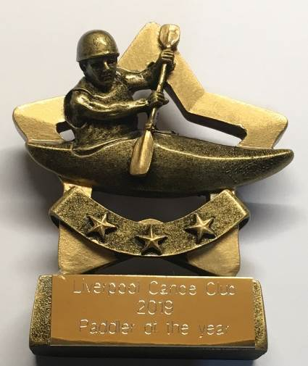
Apologies – Frankie Annan, Fiona and David Gentle, Nikki and Martin Aldridge, Craig Ellingham, Colin Smiths, John Allerton, Gareth Jones, Martin McCoy, Brian Green

7:30 – 8:00pm – Arrival Liverpool Marina, Spinnaker Suite. Slideshow / Video of club`s activities over the year.
Liverpool Canoe Club is open to all and aims "to provide the maximum canoeing and kayaking opportunities for all its members".

8:00 – 8:20pm - AGM (Election of Club Officials, Paddler of the Year, Members Motions)
Welcome from the chair & review of the year
1. Apologies for Absence.
2. Minutes of the previous AGM – Click here • Signed as a true record by the Chair • Matters arising.
3. Treasurers report Online Year End Accounts – Click here
4. Brief reports from each discipline (2 minutes each)
5. Members motions – None received to date.
6. Chair to thank all the volunteers that have coordinated and guided the club over the past year.
White Water - Stuart Toulson; SUP - Jayne Rigby; Notice boards - Peter Massey, Junior / Youth Coordinator – Ian Colwyn; SOT – Dermot Miller; Sea Kayaking – Gareth Jones; Assistant Safeguarding Officer - Karl Tattum; Club Representative - Dave Collins
7. Election of Officers – Proposed list of those willing to stand for 2019-20
Chair – Fiona Barry; Secretary – Carole Thomas, Treasurer & Grants – Craig Ford; Membership Secretary & Volunteers – Keith Steer; Lead Safeguarding Officers – Sharon Walters; Assistant Safeguarding Officer John Fay, Publicity – Pete Thomas; Junior / Youth Coordinator – Steve Alcock; Notice boards – Carl Leungs & Steve Gille; Kingsway pool on Monday Dominic Fahey; Stuart Conway; Nick Coughlin; Dave Reynolds & Keith Steer; Broadgreen pool on Tuesday Stephen Bond and Dave Reynolds
“Discipline Representatives” to advise members / act as a point of contact: Coaching Coordinator – Dave Reynolds; Polo – Josh Cook, Sea Kayaking – Ian Bell assisted by Roger Coleman; White Water – Dave and Fiona Gentle, John Cooke, John Allerton; Freestyle - Graham Devaney; Open Boat – Mike Alter & Ruth Edwards; Kayak Safety Cover –Jim Duffy assisted by Dave Rider; Slalom – Michal Giezgala; Racing – Colin Smith; Surf – Karl Tattum & Paul Harwood, SOT – Julie Brookes; SUP – Brian Green; Junior / Youth Coordinator – Steve Alcock;
Equipment Officers: Craig Ellingham & Alex Peacock Maintenance Coordinator (Docks), Steve Alcock (Docks and Broadgreen); (Kingsway) Dominic Fahey
“Election of Stewardship Group members without specific responsibility” John Pegram, Mark Benson, Martin Sinnott, Josie Moss and Richard Clews.
8:20 to 8:45pm
8. Paddler of the Year Awards presented by the chair. Please send your vote for each category by email to website@liverpoolcanoeclub.co.uk

2019 Paddler of the Year | 2019 Junior of the Year | 2019 Volunteer of the Year
Martin Sinnott | Poppy Clews | Dave and Fiona Gentle.
Kayleigh Campbell | Aleksander Ford | Stephen Bond
Chris Marsden | Reece Marsden | Dave Reynolds
Aaron Jackson | Harvey Hardwood | Ian Colwyn
Roger Coleman | Luke Durband | John Allerton

8:45 to 9:30pm – Presentations from this year’s Club trips to France, Nepal and Lofoten
(The best photos and World Premiere of - French paddling movie 2019)

9:30pm onwards – Socialise in the bar.

