Agenda AGM / Paddler of the year Awards and
club presentations of major trips Monday 19th October 2020

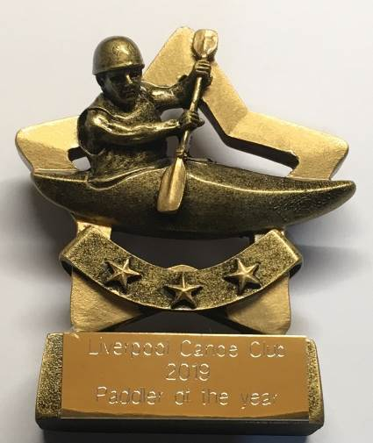
Apologies – Craig Ellingham, Julie Brookes, Dorin Wang, John Fay, Josh Cook

7:50 – 8:00pm – Slideshow / Video of club`s activities over the year.
Liverpool Canoe Club is open to all and aims "to provide the maximum canoeing and kayaking opportunities for all its members".

8:00 – 8:20pm - AGM (Election of Club Officials, Paddler of the Year, Members Motions)
Welcome from the chair & review of the year
1. Apologies for Absence.
2. Minutes of the previous AGM – Click here • Signed as a true record by the Chair • Matters arising.
3. Treasurers report Online Year End Accounts – Click here
4. Brief reports from each discipline (2 minutes each)
5. Members motions – James Duffy - defibrillator.
6. Chair to thank all the volunteers that have coordinated and guided the club over the past year especially those that given up their time to run sessions for groups of 6 during lockdown. Many canoe clubs have ceased all activities during this difficult time.
Members are reminded that volunteers give their time freely to try and get as many people on the water as possible, but we have been severely affected by the Covid 19 restrictions. Unfortunately, one or two demanding emails from newer members has resulted in several of our volunteers withdrawing their time and these sessions no longer take place resulting in even fewer paddling opportunities for other members. Such unfriendly emails are absolutely not in the spirit of the club. Alternatives exist if members want to pay for paddling and private coaching from other establishments (https://www.liverpoolwatersports.org.uk/ or https://crosbylakeside.co.uk/ or https://www.kayakessentials.co.uk/)
Standing down - John Fay – Assistant Safeguarding Officer but taking up role of inland touring representative. Brian Green – SUP Representative, Steve Gille – Notice boards;

7. Election of Officers – Proposed list of those willing to stand for 2020-21
Chair – Fiona Barry; Secretary – Carole Thomas, Treasurer & Grants – Craig Ford; Membership Secretary & Volunteers – Keith Steer; Lead Safeguarding Officer – Sharon Walters; Assistant Safeguarding Officer Lindsay Devine, Publicity – Pete Thomas; Junior / Youth Coordinator – Steve Alcock; Notice boards – Carl Leungs Kingsway pool on Monday Dominic Fahey; Stuart Conway; Nick Coughlin; Dave Reynolds & Keith Steer; Broadgreen pool on Tuesday Stephen Bond and Dave Reynolds
“Discipline Representatives” to advise members / act as a point of contact: Coaching Coordinator – Dave Reynolds; Polo – Josh Cook, Sea Kayaking – Ian Bell assisted by Roger Coleman; White Water – Dave and Fiona Gentle, John Cooke, John Allerton; Freestyle - Graham Devaney; Open Boat – Mike Alter & Ruth Edwards; Kayak Safety Cover –Jim Duffy assisted by Dave Rider; Slalom – Michal Giezgala; Racing – Colin Smith; Surf – Karl Tattum & Paul Harwood, SOT – Julie Brookes; SUP – Adya Misra; Junior / Youth Coordinator – Steve Alcock;
Equipment Officers: Craig Ellingham & Alex Peacock Maintenance Coordinator (Docks), Steve Alcock (Docks and Broadgreen); (Kingsway) Dominic Fahey
“Election of Stewardship Group members without specific responsibility” Mark Benson, Martin Sinnott, Steve Bond, Josie Moss and Richard Clews.
8:20 to 8:45pm
8. Paddler of the Year Awards presented by the chair.

2020 Paddler of the Year | 2020 Junior of the Year | 2020 Volunteer of the Year
Victor Leather | Ella Clews | Derek Connolly
Dorin Wang | Aleksander Ford | Julie Brooks
Martin Sinnott | Reece Marsden | Adya Misra
 | Charlie Murphy | Roger Coleman
 |  | Martin Sinnott
 |  | John Cooke

8:45 to 9:30pm – Presentations from this year’s Club trips to France and Skye
Team Alaska go on a Skye #staycation! Abridged Version - Ian Bell
World Premiere of – Escape from Covid – LCC French Alps 2020 by Chris Murphy

