Agenda AGM / Paddler of the Year Awards and
club presentations of major trips Monday 23rd October 2023

Location – Victoria Memorial Club, Church Road, Garston, Liverpool L19 2LW
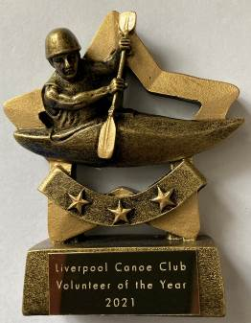
Apologies – Frankie Annan, John Cooke, Craig Ford, Karl Tattum, Mike & Cameron Fletcher, Carol Atkinson, Martin Connolly, Josie Moss, Josh Cook

7:30 – 8:00 pm – Catch up with Members - Slideshow of the club`s activities over the year.
Liverpool Canoe Club is open to all and aims "to provide the maximum canoeing and kayaking opportunities for all its members".

8:00 – 8:20 pm - AGM (Election of Club Officials, Paddler of the Year, Members Motions)
Welcome from the chair & review of the year
1. Apologies for Absence.
2. Minutes of the previous AGM – Click here • Signed as a true record by the Chair • Matters arising.
3. Honorary Treasurers report Online Year End Accounts – Click here
4. Members Survey – Analysis of the responses.
5. Brief reports from each discipline (2 minutes each)
6. Members motions – Please email any member’s motions (two emails please from the proposer and seconder) that require a LCC constitution change.
Introduction of full-time student membership and introduction of a 1 session trial (if a guest of a current member). Richard Clews
Members Questions – Please email any questions about the club, its organisation or its activities. (5 minutes max given to this item)
8. Chair to thank all the volunteers that have coordinated and guided the club over the past year, especially those that have given up their time to run sessions for its members. Members are reminded that volunteers give their time freely to try and get as many people on the water as possible.
9. Election of Officers – Proposed list of those willing to stand for 2023 – 2024 (To be confirmed during the meeting with a vote from those present)

Chair – Andy Garland Roy McHale
Chair – Roy McHale Gary Edwards
Secretary – Josie Moss
Honorary Treasurer and Grants– Craig Ford (Subject to confirmation of the auditing process going forward)
Membership Secretary, Volunteer & Safety Coordinator – Keith Steer (Subject to confirmation of the auditing process going forward)
Lead Safeguarding Coordinator – Sharon Walters Amy Newnham
Assistant Safeguarding Coordinator Carol Atkinson
Junior / Youth Coordinator –Richard Clews
Coaching Coordinator – Adya Misra Keith Steer
Compound and Boat Maintenance Coordinator - Alex Peacock
“Discipline Coordinators” to develop a team to help develop the discipline within the club:
Canoe Polo Coordinator – Callum Cook
Sea Kayaking Coordinator – Ian Bell
White Water Coordinator– John Cooke, Harry Ruggles
Freestyle Coordinator –- Harvey Harwood Paul Harwood
Surf Coordinator – Karl Tattum
SUP Coordinator –Natasha Darling
Inland Touring Coordinator – David Hendry Carl Leungs
Paddle-Ability Coordinator –- Chris Marsden
Open Boat Coordinator –Nikki Aldridge
Kayak Safety Cover Coordinator – Jim Duffy
Racing Coordinator – Colin Smith

Stewardship group members without specific responsibilities - Mark Benson, John Allerton, James Gerrie, Adya Misra
Josie Moss, Steve Bond Dave Reynolds Paul Harwood,

8:20 to 8:45pm
10. Paddler of the Year Awards presented by the chair.

2023 Paddler of the Year

2023 Young Paddler of the Year

2023 Volunteer of the Year

8:45 to 9:30pm – Presentations from this year’s Club trips to Ireland and the French Alps

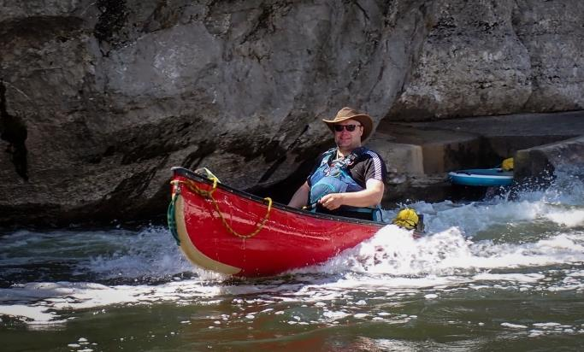  Multiday Open Canoe Trip to Massif Central | 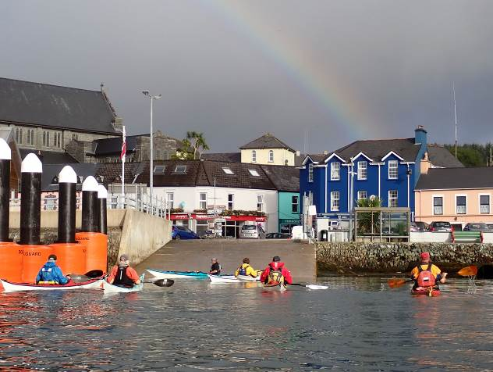  Celtic Sea Kayaking Trip (West Coast of Ireland) | 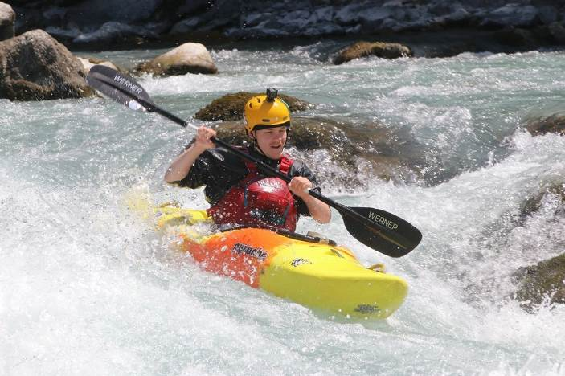  French Alps – Club Alpine Holiday

