News Article  Other News Articles | LCC Home  Site Map  Page last updated
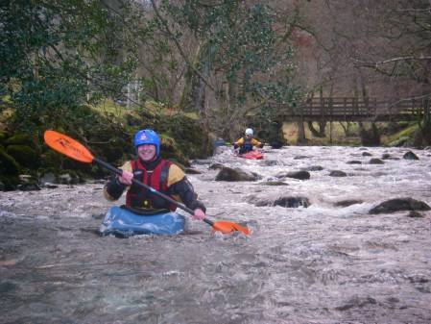
21/12/06 The Greta, no the Crake, no the Greta, no the …….Derwent
With a desire to continue the development of paddlers river skills within the club, I decided to run another trip that would enable paddlers to progress. In search of a river that would meet these needs I racked my brains, that didn't take very long, and came up with the Greta in the Lake District. However whilst researching I became aware of a slight water quality problem so decided to go for the Crake, a river that starts easy and builds in seriousness to a nice G3 rapid, instead.
However, it then rained, and rained, and rained. Seeing as the Crake is a lake fed river it holds water for a while, and I soon received reports that it was absolutely tonking! Oh well, determined to go somewhere I issued the call with the note that if not the Crake we could either find another river or go walking.
My usual paddling partners, Ruth and Ian, said that they were keen to go, and then the LCC replies flooded in! First one said he was really keen to go and get some paddling done, but that was later retracted when the "Way of the White Water Warrior" had to give way to the "Way of the Wife" and he went Christmas shopping instead! Then a second arrived, whoo hoo, but I was not really sure if it counted as it simply said, "Remind me not to drink again!"
Oh well, it was back to just Ruth, Ian and myself - so we decided to risk the Greta as it is such a fantastic river. I have only paddled it once in spate, and was really looking forward to paddling it at such levels again! So we headed off, it was rather cold that morning, stopped off at the services for tea and teacakes, and eventually arrived at the put in where we got changed.
Whilst getting ready, we noticed that they had amended the river access agreement to state - "You can paddle the river any time, accept in November and December when it must be above the white marker on the bridge stanchion." No worries, with all this rain it will easy be high enough. Finding the white marker, I was surprised to see that despite high, the river was only just touching the marker. Personally I believe that the level has been set way too high as I have paddled the river at about 0.6 - 1m below the level that it was currently running with no problems in the past.
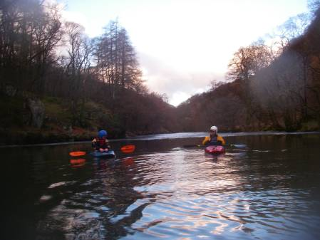
No worries, at least it was touching, so leaving one paddler with the boats we did the shuttle. By the time we had returned to the start, the boats had been moved to the get in. With a final check we started getting ready to get on. Alas at that very moment three rather large fishermen turned up and asked, "Are you going to paddle the river?" Standing in full paddling kit besides our boats I thought that that was a bit of a daft question, but answered yes. "Oh no you're not" came the reply, "the level isn't touching the marker!" Looking over I saw that in the time taken to do the shuttle the river had dropped, so it was no paddling for us. Darn! (Since learnt that we have been reported to the RAO)
With a rueful glance at the river, it looked a really nice level, we headed back to the cars to continue our search for water. Eventually we ended up in Borrowdale, where the Derwent (G2) was at an ok level. So with snow on the hills, I get new pogies for Christmas, we launched our craft for a gentle run down from Seathwaite past the youth hostel to Grange. Fantastic! I would recommend this river for a nice gentle run, and with enough water it would be great in opens (the lower section is always runnable and a good summer trip is setting off in opens and heading downstream onto Dewent Water where it is possible to camp/bivvy on the islands) ! Perfectly peaceful, there was no intrusive noise, we paddled down enjoying the view until we met an elderly couple in their open boat. A quick chat and it was off to the get out.
Just getting off, we saw the elderly couple hit a tree and end up in the water. After rescuing their paddles we went to help rescue their boat, it was a good job we were there as the boat was semi submerged and holding tight. So with our help the boat was rescued and we gave them some advice that they might wish to consider purchasing some flotation!
After that it was a case of recover the cars and head home. But the Greta is waiting, and the water level agreement runs out on the 31st of December, so I will be going back to run it at whatever the level. Mike Alter Photos......

