News Article  Other Major Trip Reports.… | LCC Home  Site Map  Page last updated
26/10/07 2007 Scottish White Water Week(end)
Four of us tagged along on Chris Scullions Scottish week but could only make the weekend. Unfortunately due to the logistics we didn't end up paddling with the main group but we did have a cracking weekend of Paddling. The group consisted of Joanne (Mountain biker and Shuttle bunny), Nick L (River guide), Greg S & Greg McC (Nicks Clients)
After a long drive the North we arrived at Roy Bridge (well actually miles from Roy Bridge but guess that is the closest place to it). Greg S and Nick decided to Crack open the beers. Unfortunately someone had forgotten to bring it. Not to worry, early to bed and all - granted it was mid-night!
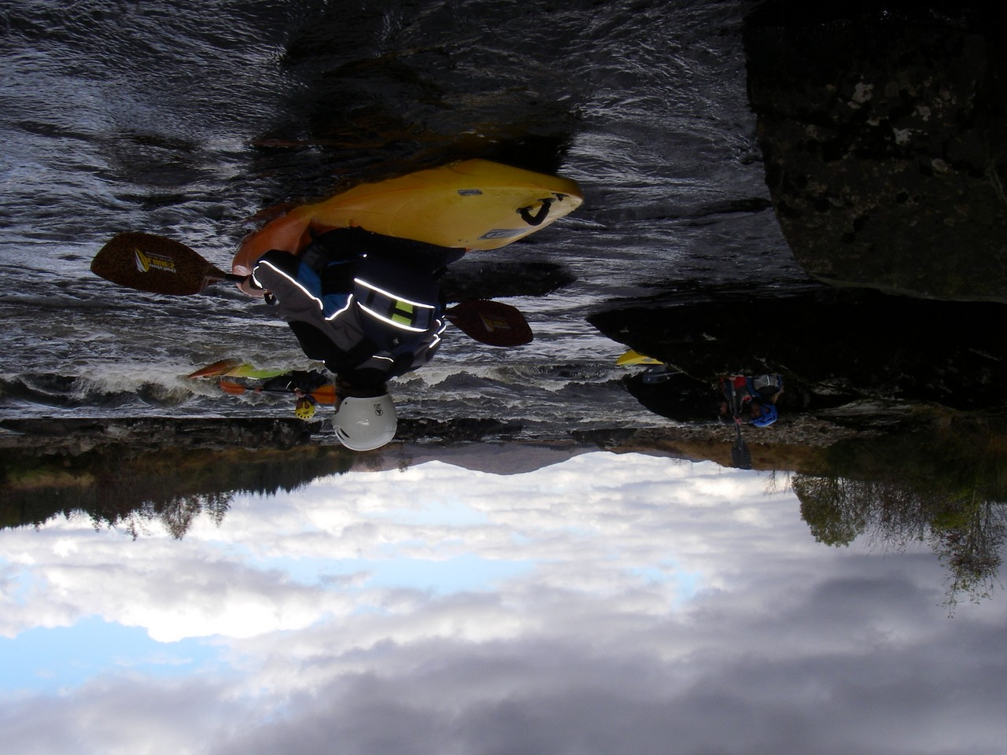
Up early and on the water by 8:45. Good job someone forgot the beers! First River was the Spean gorge. Nick doing a Stirling job directing us to the start and guiding us down the river. Lots of 'er, think there is something ahead' as a large horizon line appeared. Like Greg S & McC wouldn't have noticed. What would we have done without him! The river however was fantastic. I even learnt a new technique for deciding who runs the rapid first. Not to give too many of Coach Nick's techniques away other than to say that paper wraps the stone!
The second river of the day was the Roy gorge. What can I say? This is the most stunning section of river I think I have ever paddled. Absolutely gorgeous scenery and great white water. Nick was on form pointing out rapids and other features the two Greg's would never have spotted. One particular rapid our guide got out of his boat and positioned himself well on a rock next to a particular tricky section. He gave a perfect description of the rapid to us… at least the bit we could see. Greg McC went first and made it through (granted this was more luck than skill). Greg S was a little less lucky. However, Guide Nick did point out that Greg S did the same he had done the previous year. Consistency. Wonderful! The rest of the river was most enjoyable although a little daunting that our guide kept telling us the end was just around the corner!
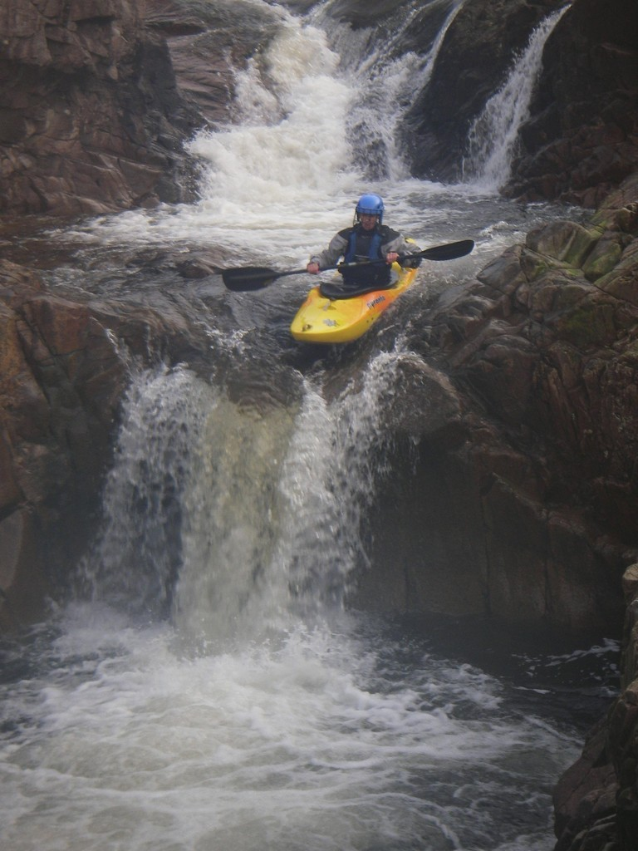
Saturday night was spent in a nice comfy pub with good food and the Rugby. We met the rest of the club party there and had a very pleasant evening. The two Greg's trying to soak up guide Nick's valuable knowledge of the local rivers. That didn't take long so we mainly spoke about Paul Daniels and his magic!
Sunday was another early dart. On the River Etive by 9:30. Guide Nick allowed his boat to have a warm up on the river by itself before we all got on. What a river! Although a little dry, all the drops had enough water to paddle. Shuttle Bunny Jo aided Guide Nick with pointing out the tricky bits… wherever there is a Jo, there is a drop. Each drop took a bit of Scouting but all but one where paddleable. I have read comments on this river being the most photographed river around and can see why. Shame we didn't have a camera! Yes, as well as forgetting the Beer, someone forgot the Camera!
The final river was the Orchy. The mighty Orchy. Perhaps mighty some days but today it was a bump and scrape. After three wonderful rivers this was a little depressing. That said, we did stumble across 2 really good rapids but by the time we came upon the first portage we had had enough and aborted the river. Guide Nick informing it must be only a mile back to the car. With Shuttle bunny off enjoying a lovely cycle in the nearby forest (or was it a hard slog through mud?), I walked back to get the car. One mile my ~@?%. After about two miles I was picked up by some friendly paddlers and given a lift back to the car.
All in all a brilliant weekend. Shame the rivers where low but still really enjoyed it. A big thanks to Chris Scullion for organising and to Nick for guiding us. Oh and Jo for driving around after us. Sorry no photo's but someone forgot the camera. Just means we will have to go back again! (Illustration Photos from the main group)

