News Article  Other News Articles | LCC Home  Site Map  Page last updated
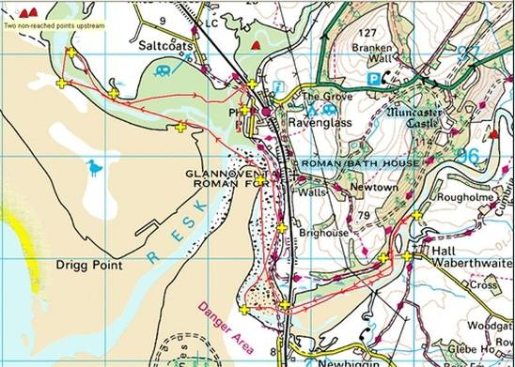
14/04/08 Seaquest at Ravensglass (Sea Kayaks and Open Boats)
What do you get if you cross orienteering with sea kayaking?
The answer, Seaquest.
With a bit of anticipation, especially given the weather, three club members turned up at Ravenglass for the 2nd Ravenglass Seaquest with not a clue as to what was about to happen on a three hour event that wasn't due to start until 3.30pm.
Registration was going fine as we advised of our boat types, buoyancy aid colour etc, but then came time to give our team name. "Liverpool", was the obvious answer which was then followed by the registrars response of "Ah, a local team, you should have a good knowledge of this area then?" She looked confused when we advised we wouldn't as we where from Liverpool.
Armed with our map of checkpoints and logbook to annotate, rather than work out the best route given the tide and wind conditions we decided to have a natter and check out the competition. Families in open canoes (some with sails), slalom boats, dancers, and other various sea kayaks, easy! Err, no. Some people were a being bit more competitive than Team LCC and had arrived with full on racing boats. They also appeared to be rather busy making plans as to the best route.
So, faced with several other athletes of similar top class ability as ourselves we decided to prepare. We therefore packed the boats with high energy foods (Mars bars / Packets of crisps), planed the most high scoring route for the three hours allowed and making best use of conditions (That way looks nicer) and most importantly got the excuses ready (Everyone has longer paddles than us). After that it was off to the pre-race safety briefing, and then begin setting up for the Le Mans style start - boats 1m back from waters edge, everyone 5m back from their boats.
A wave of a flag and we were off!
Well sort of, many boaters quickly paddled off whilst Team LCC failed to notice the start and with a shocked "Oh, they've started" strolled over to our boats and struggled with spraydecks - you can tell that we were taking this racing seriously can't you?
Finally off! We hit several checkpoints with ease before running aground on a sandbank whilst going for point 2. Some quick team tactics - that looks like too much walking, lets get it on the way back when the tide has come in a bit - and with that on the hoof planning we were off again.
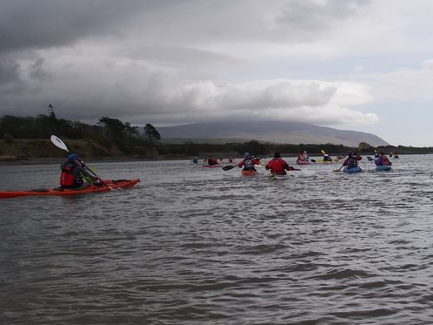
Checkpoint 13 saw me doing my best David Hasselhoff impression, running along the beach in full kit really is not my best look, whilst Greg disappeared in the mud at checkpoint 4 - Jo and I politely pretended not to notice and paddled off.
It was then that lack of route planning came into play when we had to paddle against both wind and tide. Ow! It was now half way into the event, so we stopped at checkpoint 9 for a bite to eat. "You haven't got time to eat!" was a cry from a fellow competitor, "Why, this is our last point" was Greg's quick reply - I'm not sure if he believed us?
So stocked up with quality energy foods we paddled on. The normally non-competitive me started pushing for that extra point and I soon got the name of Nigel, apparently he is someone who used to play polo and is quite competitive, but that soon faded as I ran out as energy in the closing minutes. But what we all agreed was that even though it was a fun event, having check points did push us all on to explore that bit more.
This is a great event. You can take it as seriously or as fun filled as you want and you can do it in any craft in a sheltered, safe and rather pleasant environment. I plan to be back next year and would strongly recommend that the club send a larger contingent as there is a really good social aspect attached - campsite at the finish / food laid on at the post race prize ceremony in the local pub.
And finally to the important bit, where did we finish??????
Well, unfortunately all of Team LCC had to get away and so we don't know were we finished. Whilst we never reached all the points, some paddlers did well within the 3 hour limit, I have a sneaky feeling that we may well have won our class (old farts with short blades in plastic boats) given that we paddled 12.3km in a time of 2hr48min with an average speed of 4.37kph and a top speed of 10.1kph!
We will find out soon and provide an update. Photographs...... .......
Mike, Greg and Jo

